1. Working with java.lang.Boolean
a. Explore the Java API documentation for java.lang.Boolean and observe its modifiers and super types.
b. Declare a method-local variable status of type boolean with the value true and convert it to a String using the toString method. (Hint: Use Boolean.toString(Boolean) ).

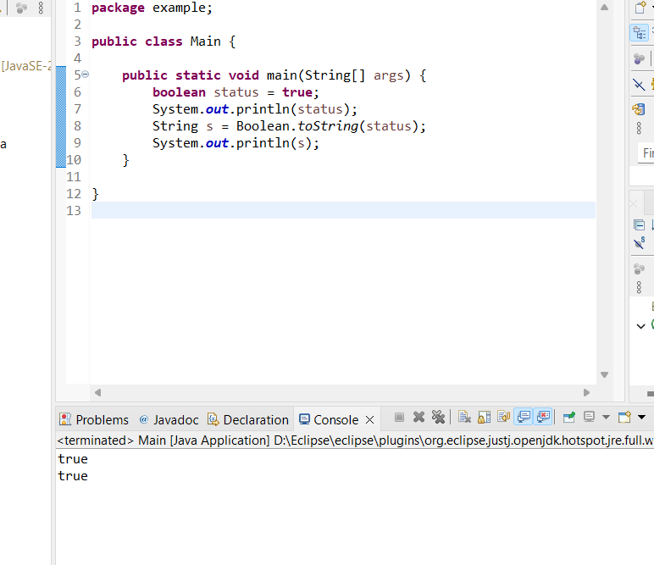

c. Declare a method-local variable strStatus of type String with the value "true" and convert it to a boolean using the parseBoolean method. (Hint: Use Boolean.parseBoolean(String)).

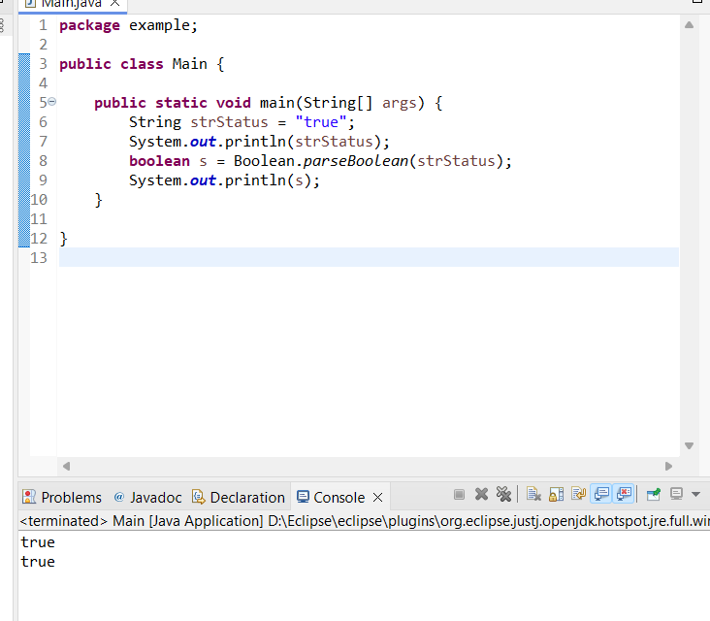

d. Declare a method-local variable strStatus of type String with the value "1" or "0" and attempt to convert it to a boolean. (Hint: parseBoolean method will not work as expected with "1" or "0").

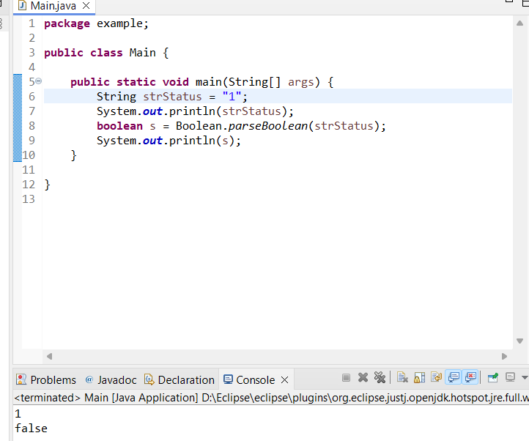

e. Declare a method-local variable status of type boolean with the value true and convert it to the corresponding wrapper class using Boolean.valueOf(). (Hint: Use Boolean.valueOf(boolean)).

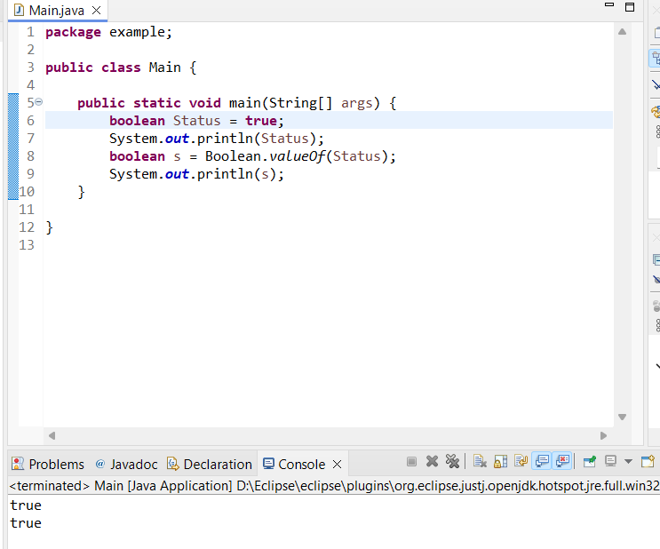

f. Declare a method-local variable strStatus of type String with the value "true" and convert it to the corresponding wrapper class using Boolean.valueOf(). (Hint: Use Boolean.valueOf(String)).

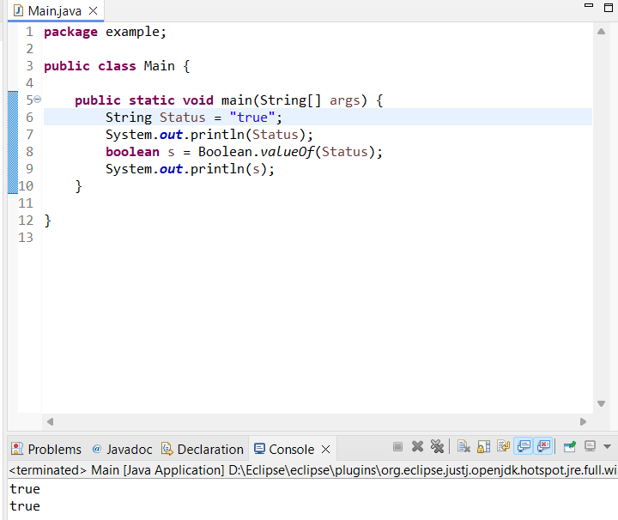

2. Working with java.lang.Byte

a. Explore the Java API documentation for java.lang.Byte and observe its modifiers and super types.
b. Write a program to test how many bytes are used to represent a byte value using the BYTES field. (Hint: Use Byte.BYTES).

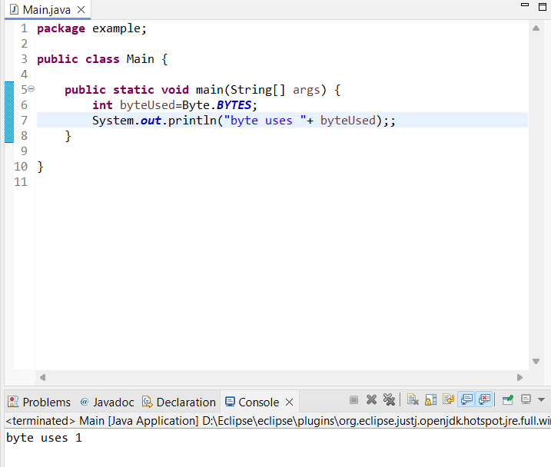

c. Write a program to find the minimum and maximum values of byte using the MIN_VALUE and MAX_VALUE fields. (Hint: Use Byte.MIN_VALUE and Byte.MAX_VALUE).

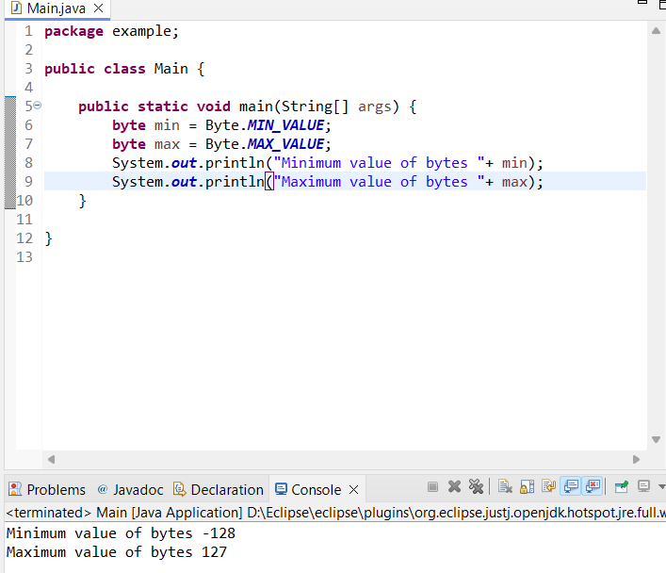

d. Declare a method-local variable number of type byte with some value and convert it to a String using the toString method. (Hint: Use Byte.toString(byte)).

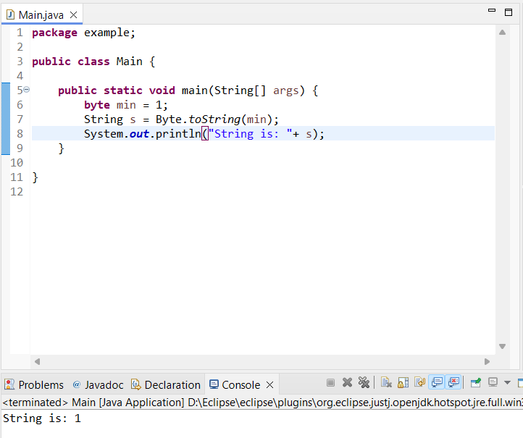

e. Declare a method-local variable strNumber of type String with some value and convert it to a byte value using the parseByte method. (Hint: Use Byte.parseByte(String)).

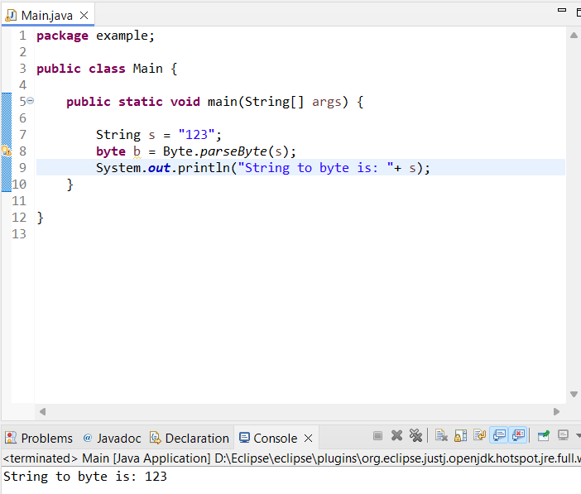
f.Declare a method-local variable strNumber of type String with the value "Ab12Cd3" and attempt to convert it to a byte value. (Hint: parseByte method will throw a NumberFormatException).

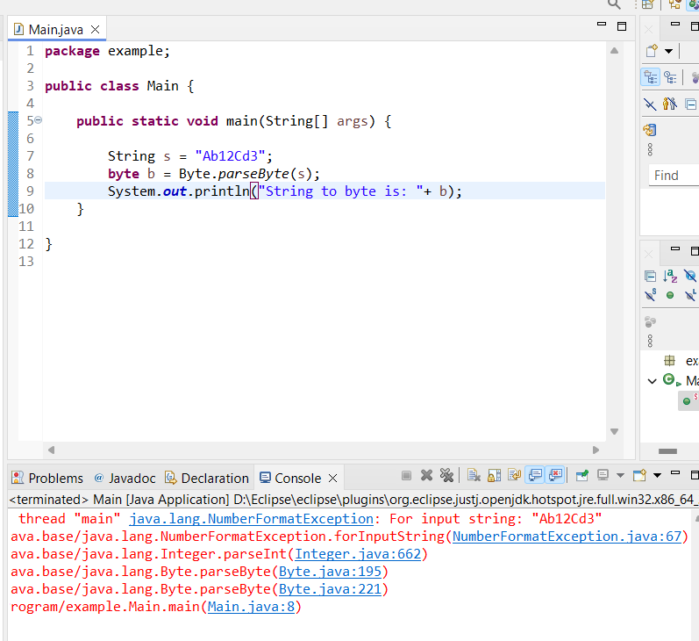

g. Declare a method-local variable number of type byte with some value and convert it to the corresponding wrapper class using Byte.valueOf(). (Hint: Use Byte.valueOf(byte))

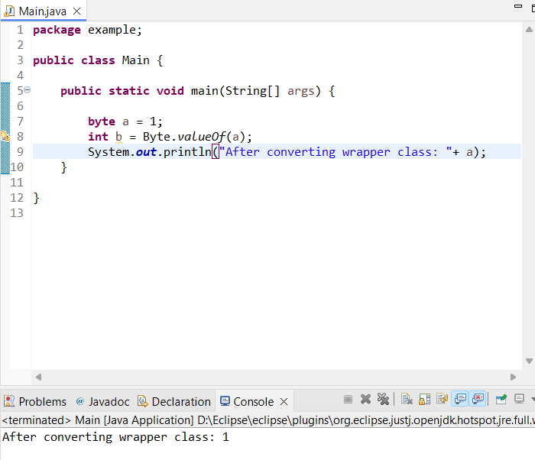

h. Declare a method-local variable strNumber of type String with some byte value and convert it to the corresponding wrapper class using Byte.valueOf(). (Hint: Use Byte.valueOf(String)).

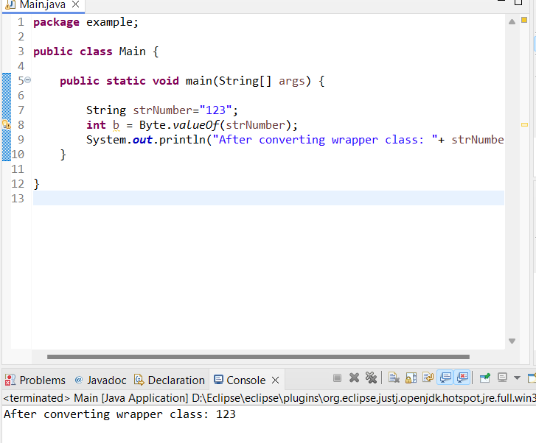
3. Working with java.lang.Short

a. Explore the Java API documentation for java.lang.Short and observe its modifiers and super types.
b. Write a program to test how many bytes are used to represent a short value using the BYTES field. (Hint: Use Short.BYTES).
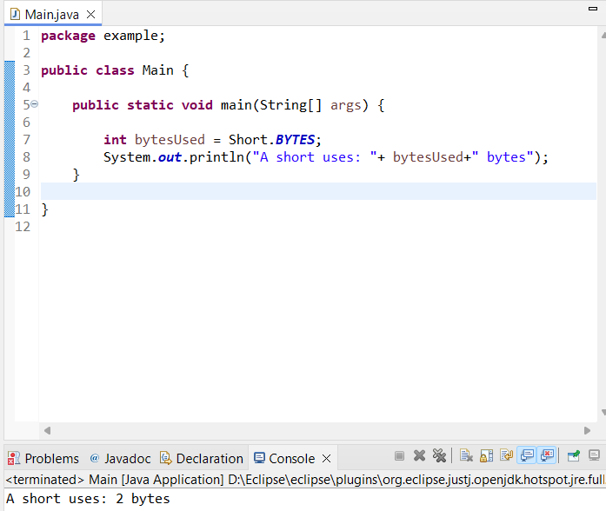
c. Write a program to find the minimum and maximum values of short using the MIN_VALUE and MAX_VALUE fields. (Hint: Use Short.MIN_VALUE and Short.MAX_VALUE).
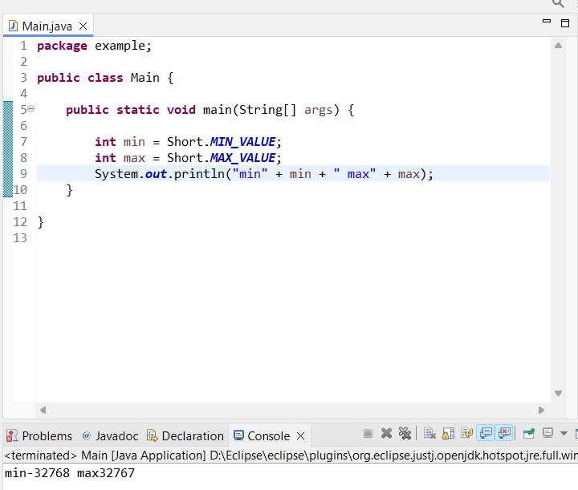
d. Declare a method-local variable number of type short with some value and convert it to a String using the toString method. (Hint: Use Short.toString(short)).
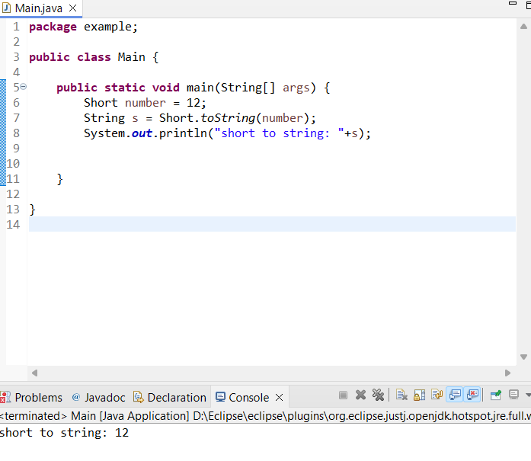

e. Declare a method-local variable strNumber of type String with some value and convert it to a short value using the parseShort method. (Hint: Use Short.parseShort(String)).
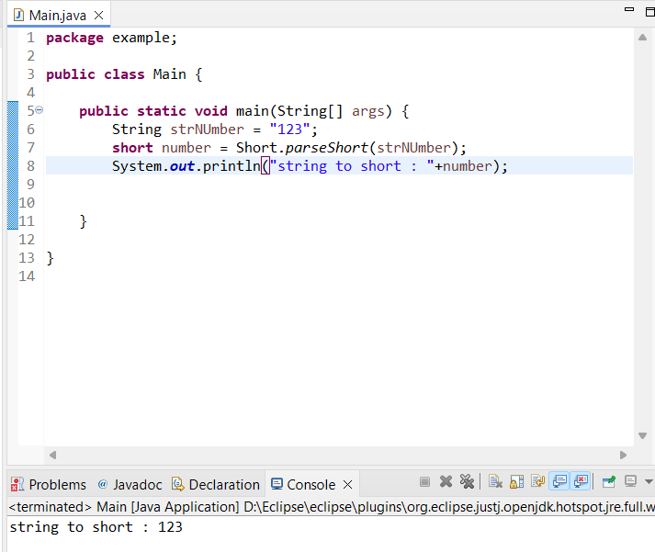
f. Declare a method-local variable strNumber of type String with the value "Ab12Cd3" and attempt to convert it to a short value. (Hint: parseShort method will throw a NumberFormatException).

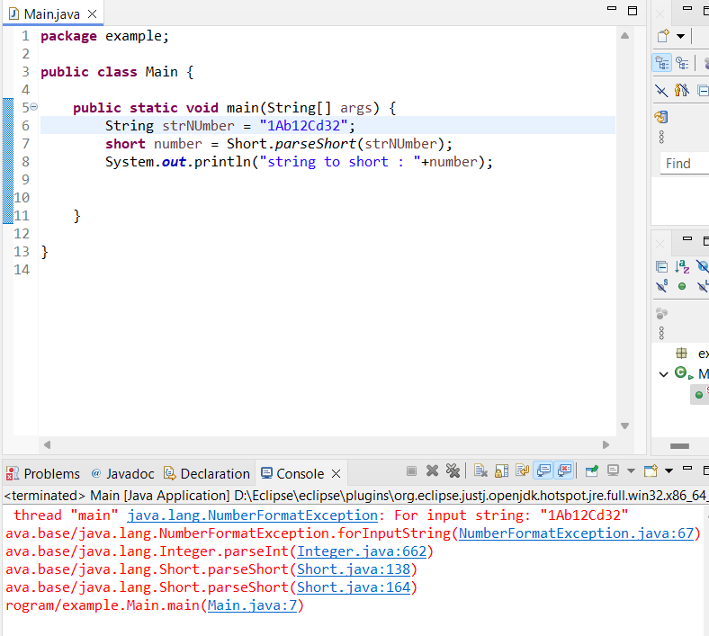

g. Declare a method-local variable number of type short with some value and convert it to the corresponding wrapper class using Short.valueOf(). (Hint: Use Short.valueOf(short)).

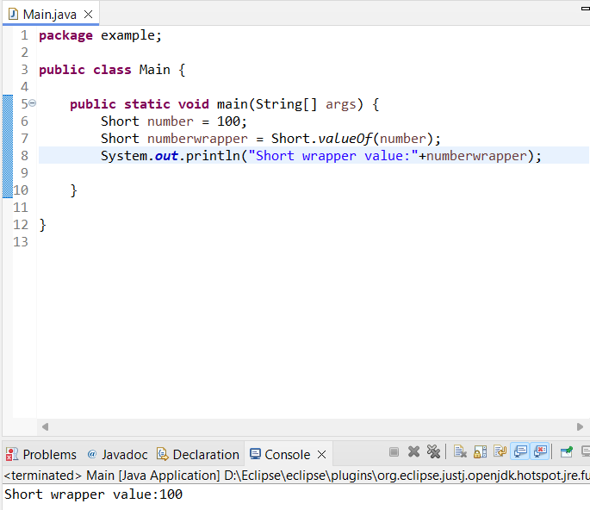

h. Declare a method-local variable strNumber of type String with some short value and convert it to the corresponding wrapper class using Short.valueOf(). (Hint: Use Short.valueOf(String)).
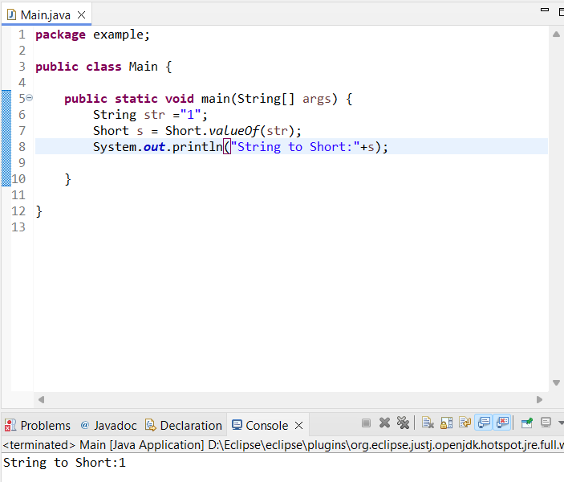

4. Working with java.lang.Integer

a. Explore the Java API documentation for java.lang.Integer and observe its modifiers and super types.

b. Write a program to test how many bytes are used to represent an int value using the BYTES field. (Hint: Use Integer.BYTES).
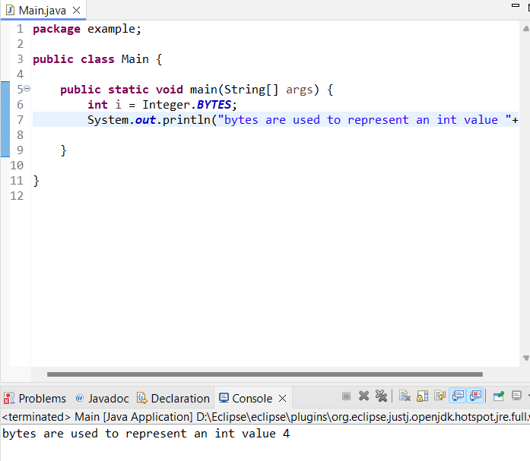
c. Write a program to find the minimum and maximum values of int using the MIN_VALUE and MAX_VALUE fields. (Hint: Use Integer.MIN_VALUE and Integer.MAX_VALUE).
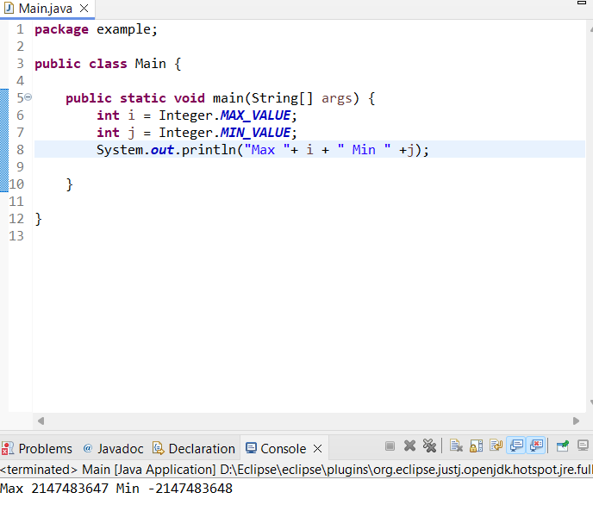
d. Declare a method-local variable number of type int with some value and convert it to a String using the toString method. (Hint: Use Integer.toString(int)).
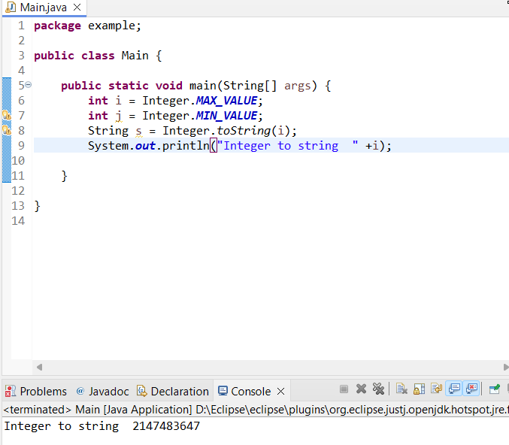
e. Declare a method-local variable strNumber of type String with some value and convert it to an int value using the parseInt method. (Hint: Use Integer.parseInt(String)).
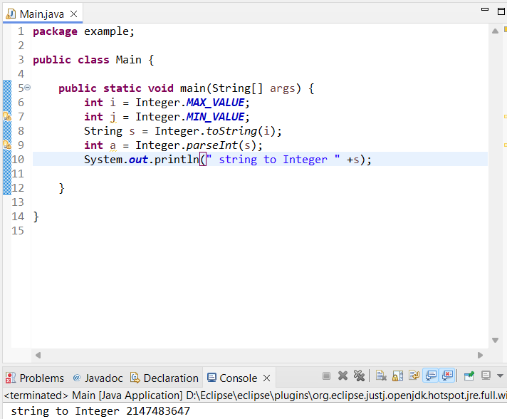

f. Declare a method-local variable strNumber of type String with the value "Ab12Cd3" and attempt to convert it to an int value. (Hint: parseInt method will throw a NumberFormatException).
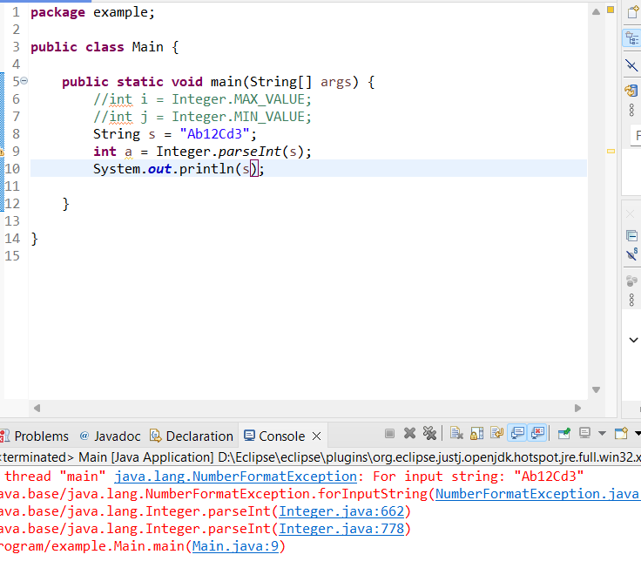
g. Declare a method-local variable number of type int with some value and convert it to the corresponding wrapper class using Integer.valueOf(). (Hint: Use Integer.valueOf(int)).
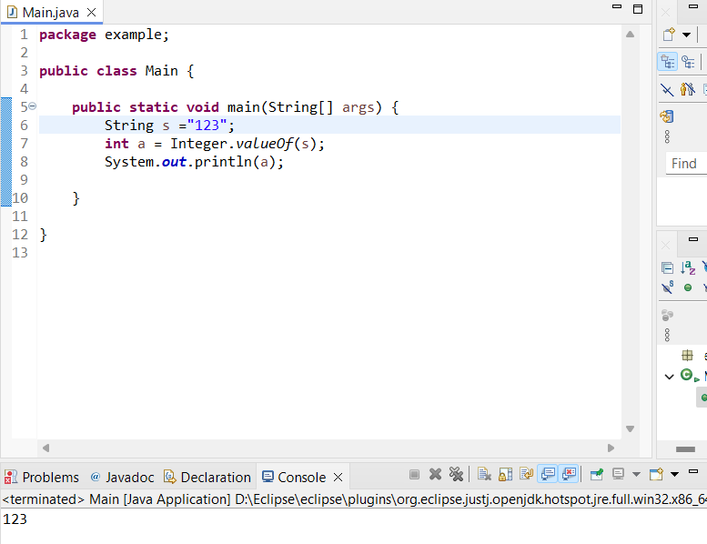
h. Declare a method-local variable strNumber of type String with some integer value and convert it to the corresponding wrapper class using Integer.valueOf(). (Hint: Use Integer.valueOf(String)).

i. Declare two integer variables with values 10 and 20, and add them using a method from the Integer class. (Hint: Use Integer.sum(int, int)).
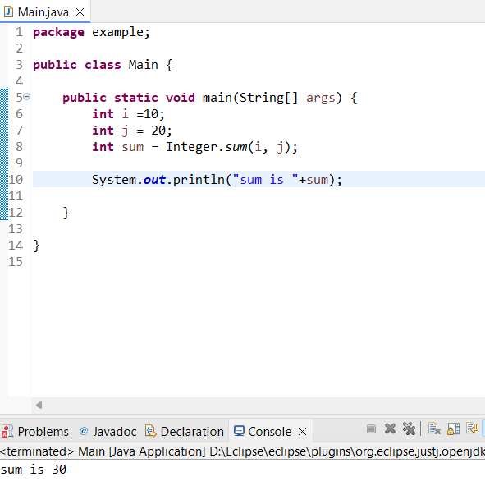
j. Declare two integer variables with values 10 and 20, and find the minimum and maximum values using the Integer class. (Hint: Use Integer.min(int, int) and Integer.max(int, int)).

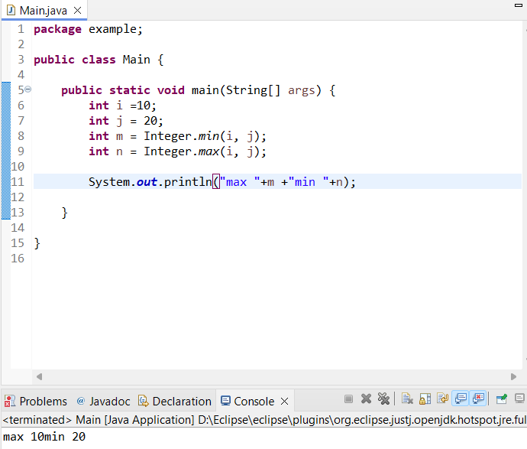
k. Declare an integer variable with the value 7. Convert it to binary, octal, and hexadecimal strings using methods from the Integer class. (Hint: Use Integer.toBinaryString(int), Integer.toOctalString(int), and Integer.toHexString(int)).

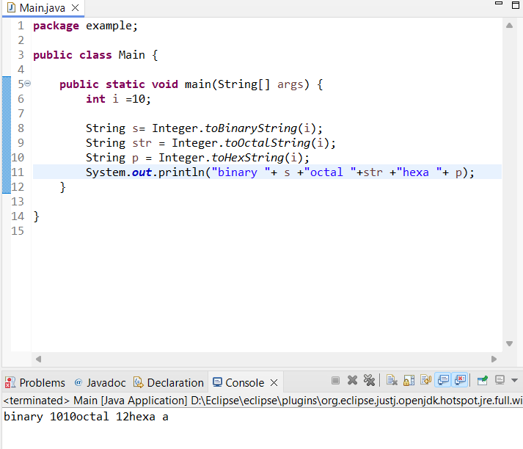

5. Working with java.lang.Long

a. Explore the Java API documentation for java.lang.Long and observe its modifiers and super types.

b. Write a program to test how many bytes are used to represent a long value using the BYTES field. (Hint: Use Long.BYTES).
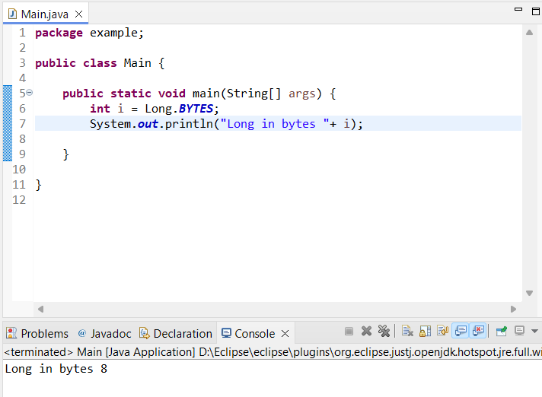
c. Write a program to find the minimum and maximum values of long using the MIN_VALUE and MAX_VALUE fields. (Hint: Use Long.MIN_VALUE and Long.MAX_VALUE).
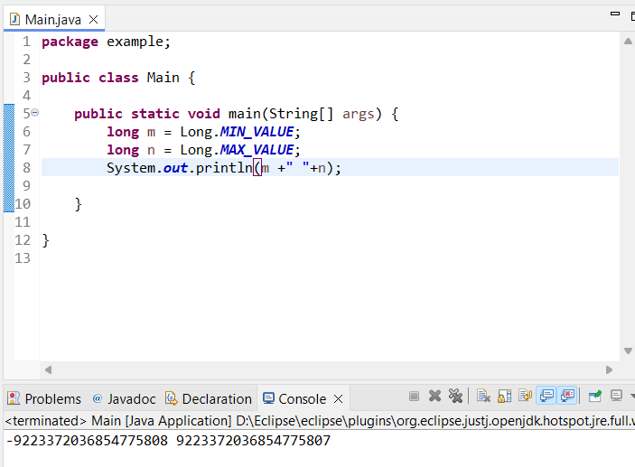
d. Declare a method-local variable number of type long with some value and convert it to a String using the toString method. (Hint: Use Long.toString(long)).
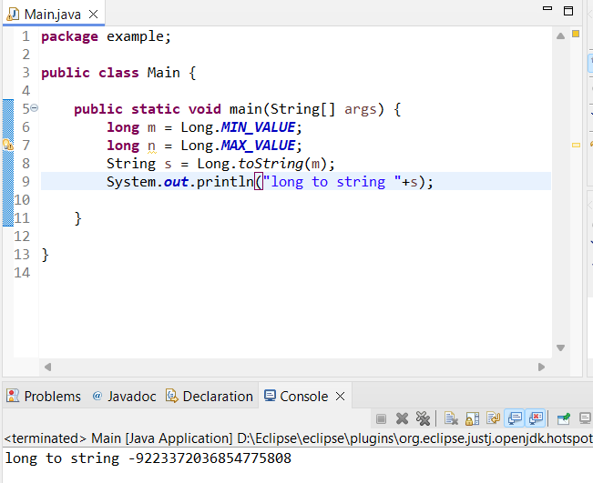
e. Declare a method-local variable strNumber of type String with some value and convert it to a long value using the parseLong method. (Hint: Use Long.parseLong(String)).
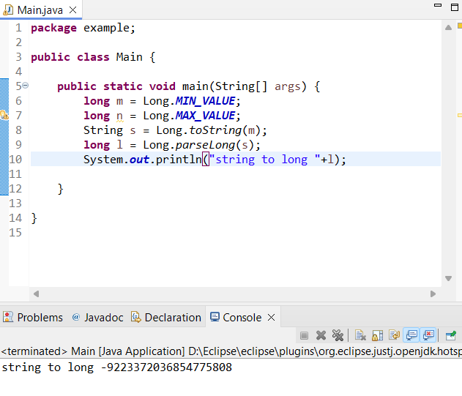
f. Declare a method-local variable strNumber of type String with the value "Ab12Cd3" and attempt to convert it to a long value. (Hint: parseLong method will throw a NumberFormatException).
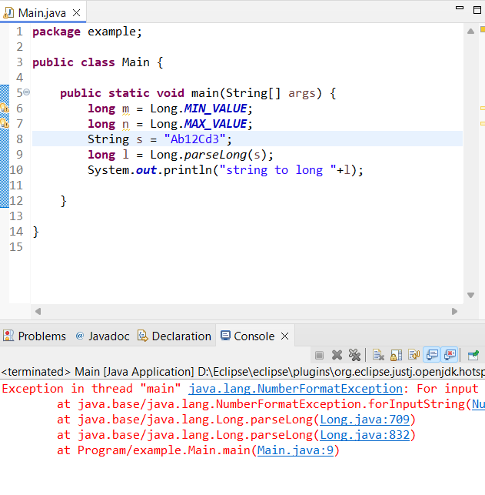
g. Declare a method-local variable number of type long with some value and convert it to the corresponding wrapper class using Long.valueOf(). (Hint: Use Long.valueOf(long)).
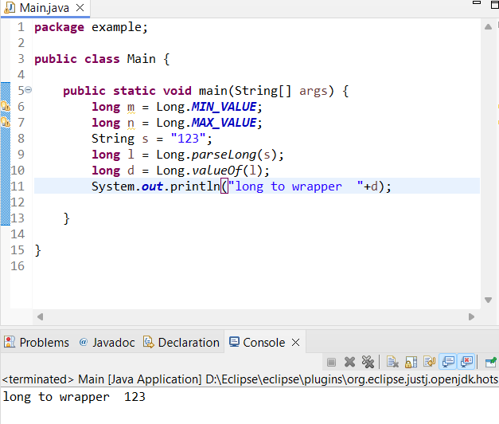
h. Declare a method-local variable strNumber of type String with some long value and convert it to the corresponding wrapper class using Long.valueOf(). (Hint: Use Long.valueOf(String)).
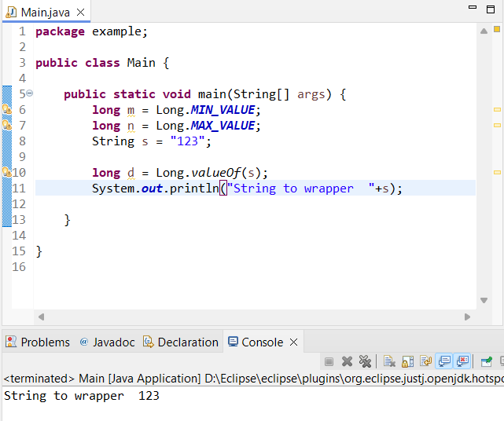
i. Declare two long variables with values 1123 and 9845, and add them using a method from the Long class. (Hint: Use Long.sum(long, long)).
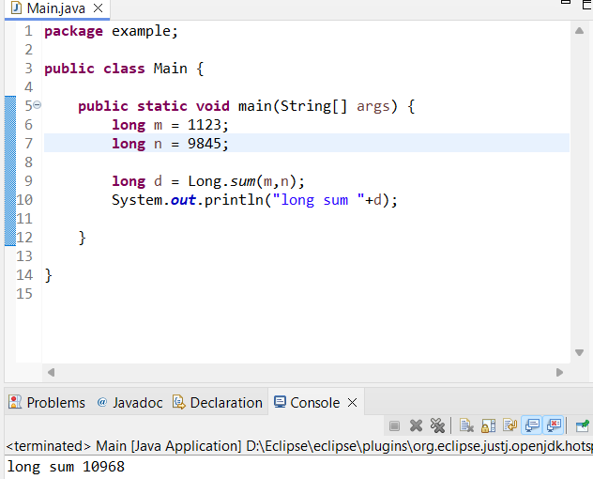

k. Declare a long variable with the value 7. Convert it to binary, octal, and hexadecimal strings using methods from the Long class. (Hint: Use Long.toBinaryString(long), Long.toOctalString(long), and Long.toHexString(long)).
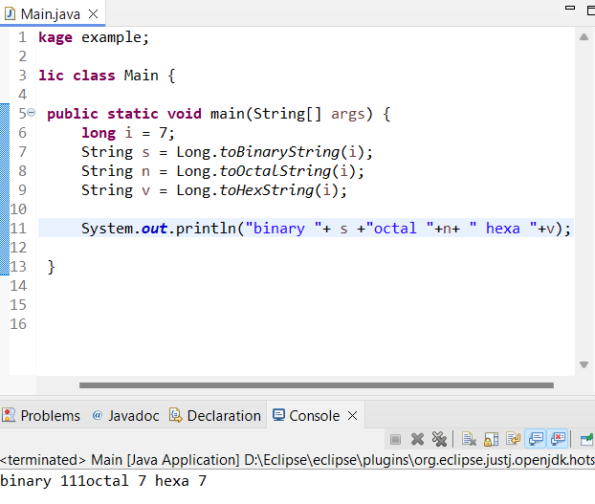

8. Conversion between Primitive Types and Strings Initialize a variable of each primitive type with a user-defined value and convert it into String:
First, use the toString method of the corresponding wrapper class. (e.g., Integer.toString()).
Then, use the valueOf method of the String class. (e.g., String.valueOf()).

